Zurich Payback Scheme(PBS)
Informix table: maa_mem
- it's a master table to store PBS detail, please see attached sample date (maa_mem). The fields no_of_amcinv, amc_nextdue, no_of_inst, inhse_nextdue just maintain as is. No usage for now
- pbs_indc: Y = Yes, N = No
- claim_indc: Y = Claimed PBS, N = No Claim Yet
- The primary key is cocode and agmt_no
- Relationship with agreements table is 1 – 1. Not all agreement has PBS

Annual Maintenance Charges (AMC)
- Please refer to the data model below you have created
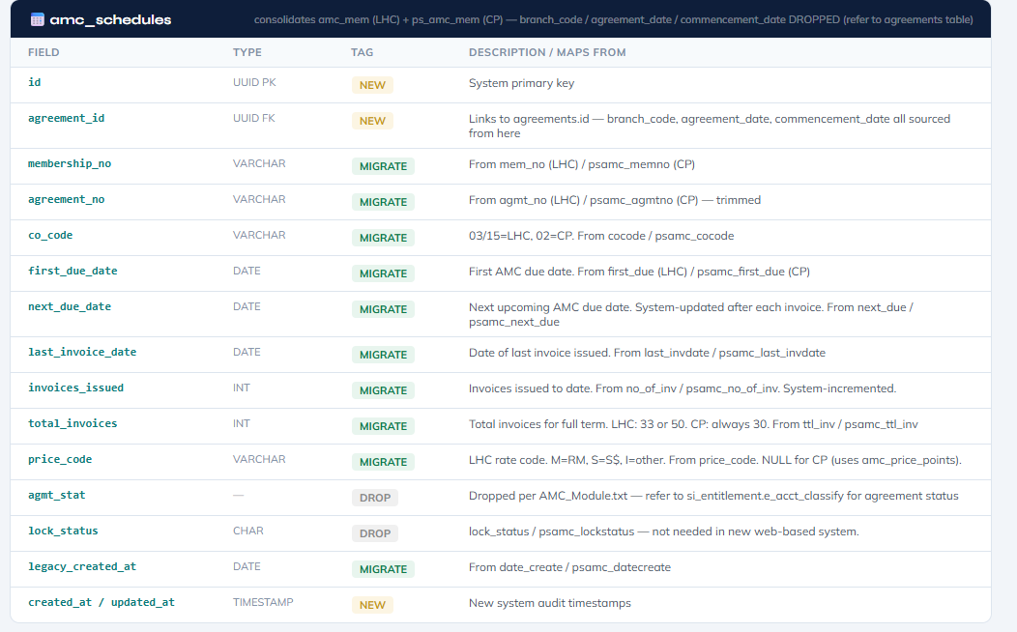

- relationship with agreement is 1 to 1
- primary key is company code, membership no, agreement no

Display Layout
- Display PBS and AMC in Agreements individual card
- No need search or filter on PBS and AMC
- PBS fields to be displayed under agreement:

- AMC fields to be displayed under agreement:

